Chapter 16, Solution 59.

Find v_{o}(t) in the circuit in Fig. 16.82 if v_{x}(0) = 2 V and i(0) = 1 A.

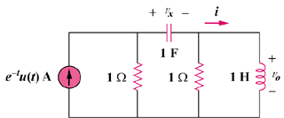

Figure 16.82
For Prob. 16.59.

Solution

We incorporate the initial conditions and transform the current source to a voltage source as shown.

1
+

V_{o}

2/s

1/s

1/s
+

1

s

1/(s + 1)

At the main non-reference node, KCL gives

Equating coefficients :
:
:
:

